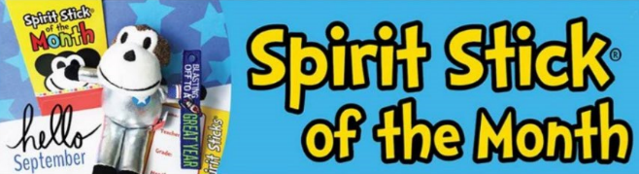

Join our new Spirit Stick of the Month Club!!
$10 FOR 10 MONTHS (Aug-May)
Join the Spirit Stick of the Month Club - your child will receive a special, SURPRISE stick delivered the first full week of each month. (Aug, Sept and Oct sticks will be delivered mid Oct). These will be exclusive sticks, only available through club membership. This will include Halloween, Christmas and Valentine Day Sticks. Believe me your kids do not want to miss out on these sticks. Membership also includes an automatic entry into a raffle to receive some exclusive Spirit Monkey chotskis and stickers books, etc. We will have a few winners per month.

Thank you for supporting our school!
Please print clearly and fill out form completely!
(Send Exact Cash or Check Only)

Student’s Name: _____________________________________________________ Girl or Boy
Student’s Homeroom Teacher: ____________________________________ Grade____________
Cash or Check______

Membership only available to the FIRST 200 forms returned.

